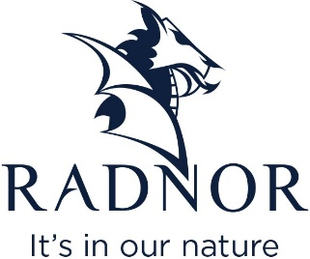

JOB VACANCY
HEAD OF ENGINEERING
About Radnor

Independent and family owned, Radnor is one of the UK’s leading soft drinks manufacturers and sells over 400 million drinks a year.

Based in beautiful countryside in the heart of Powys, Wales, environmental sustainability is at the forefront of our company and we are committed to minimising our impact. We are proud to be a zero to landfill site. We are also supporting a circular economy, sending any waste, including our plastic, back to the source to be reused and recycled. All of our plastic bottles are 100% recyclable and also made up of 30% recycled material.

We will soon open our own £1.2 million solar farm to power our manufacturing site. This will produce 21% of the company’s energy and will support our pledge to the planet to become more sustainable and to protect the environment around us.

For over 30 years, our award-winning drinks have been made using a pure spring water source running just metres from our site. We manufacture bottled, canned and TetraPak soft drinks and our customers include schools, stores and supermarkets nationwide.

The Role:

We are recruiting for the position of Head of Engineering We are looking for an experienced manager to lead our Engineering department ensuring the continuity of production through effective and efficient maintenance and engineering across the site, minimising down time, reducing costs and ensuring compliance with all regulatory requirements.
Main duties will include:
- Overall responsibility for the maintenance of all production equipment and site facilities.
- Leading a team of maintenance engineers and engineering staff providing day to day management, clear direction and identifying development needs.
- Overseeing safety programs and initiatives, ensuring that the engineering team are trained on safety procedures and equipment, and that all safety incidents are reported and addressed promptly.
- Ensure accurate and up to date records of maintenance control activities including inspections, testing and audits of equipment.
- Responsible for managing the engineering budget, ensuring that costs are kept within the approved budget limits. Identifying areas for cost savings and work with the team to implement cost-saving initiatives while maintaining quality standards.
- Development and implementation of a PM program.
- Provide expertise, guidance and training on maintenance-related matters to the wider team.

Candidate requirements:
- Experienced people manager with relative industry experience and ideally, an in-depth knowledge of soft drinks production processes, equipment and quality control systems.
- Excellent Health and Safety awareness.
- Able to plan and organise work schedules in a fast-paced environment and meet deadlines.
- Excellent attention to detail.
- Professional, approachable with outstanding interpersonal skills.
- Ability to lead by example.
- Technically minded with a passion for problem solving.
Hours and Location:
Our factory is based in Knighton and you will work 40 hours per week, Monday to Friday, 0800 to 1600 however flexibility will be required to meet the needs of the business.
If you have what it takes to join our team, we’d love to hear from you! Please send your current CV and covering letter to jobs@radnorhills.co.uk

